Compare Procedural Programming and object oriented programming
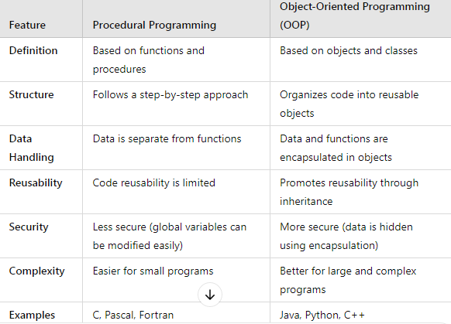

Abstraction
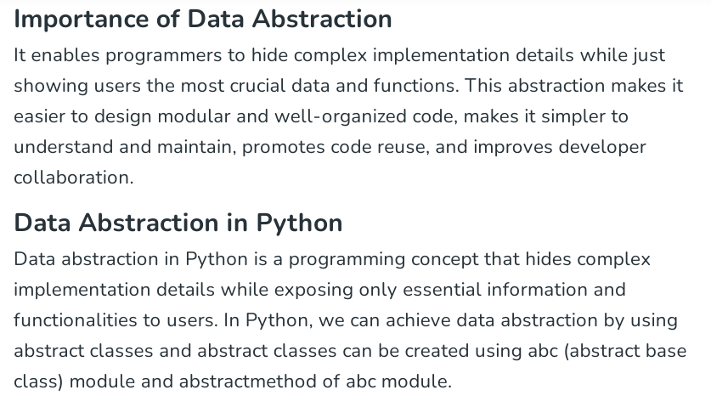

Encapsulation
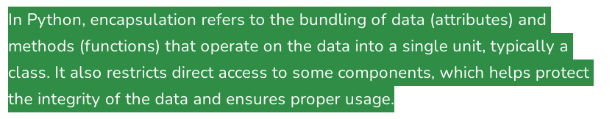
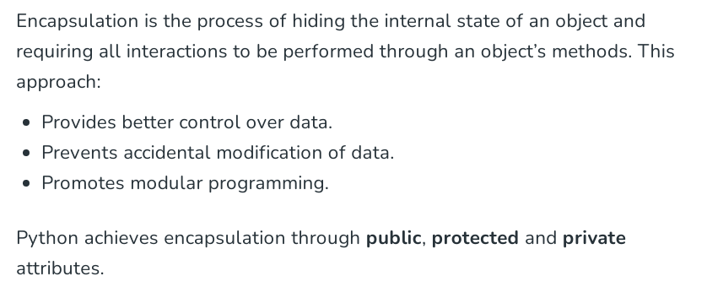

What is class and object ?

Class
- A class is a blueprint for creating objects.
- It defines attributes (variables) and methods (functions) that objects will have.

Object
- An object is an instance of a class.
- Each object has its own values for instance attributes.

Types of Constructors
A constructor is a special method (__init__) used to initialize an object when it is created.

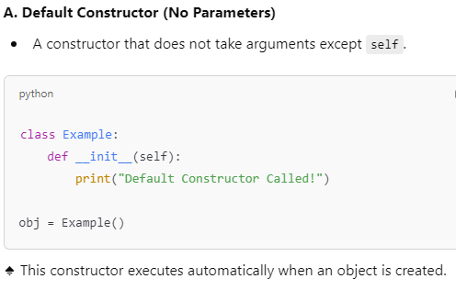
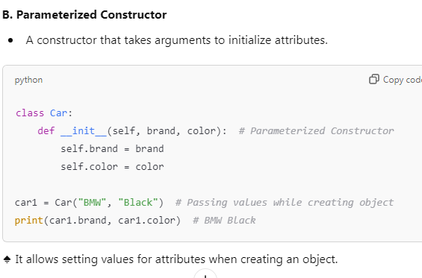
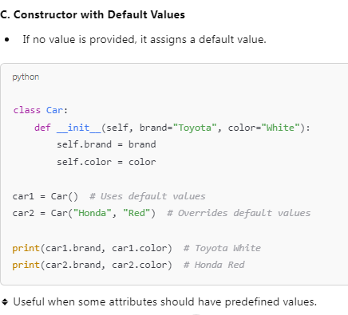
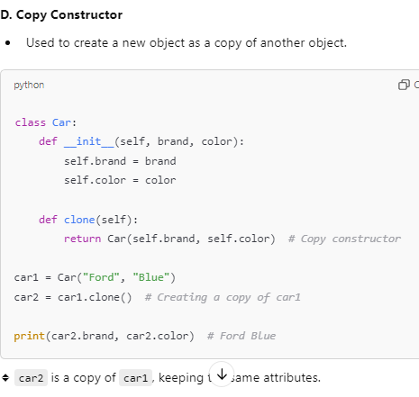
Instance variable and methods
1.Instance variable
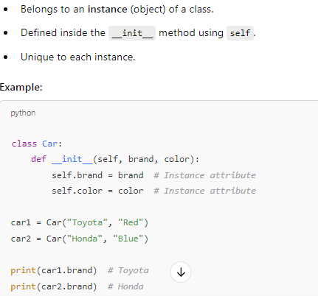

brand and color are instance attributes because they are specific to each car object.

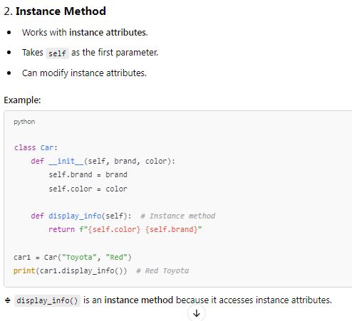

Class Attribute
- Shared by all instances of the class.
- Defined outside the __init__ method.

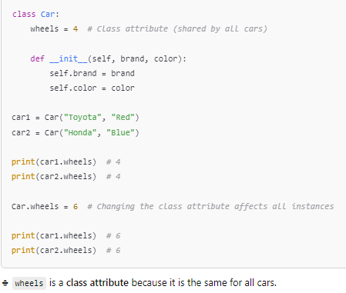

Class Method
- Works with class attributes.
- Takes cls (class) as the first parameter.
- Can modify class attributes.

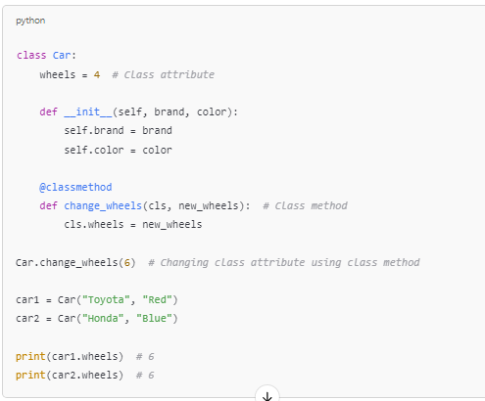

🔹 change_wheels() is a class method because it modifies the class attribute wheels.

Inheritance in Python - Student Notes

What is Inheritance?
Inheritance is an object-oriented programming (OOP) concept that allows one class (child class) to inherit properties and behaviors (methods) from another class (parent class). This promotes code reusability and hierarchical relationships between classes.

Types of Inheritance in Python
- Single Inheritance - One child class inherits from one parent class.
- Multiple Inheritance - A child class inherits from multiple parent classes.
- Multilevel Inheritance - A class inherits from a child class, forming a chain.
- Hierarchical Inheritance - Multiple child classes inherit from a single parent class.
- Hybrid Inheritance - A combination of two or more types of inheritance.

1. Single Inheritance
In single inheritance, a child class derives from a single parent class.

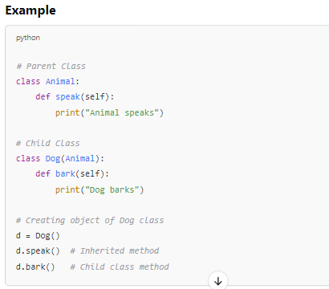

Explanation
- The Dog class inherits the speak() method from Animal.
- The Dog class also has its own method bark().

//==================================

2. Multiple Inheritance
In multiple inheritance, a child class can inherit from more than one parent class.

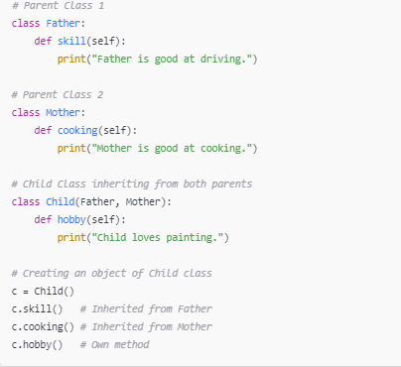

Explanation
- Child class inherits methods from both Father and Mother.
- It also defines its own method hobby().

3. Multilevel Inheritance
In multilevel inheritance, a class derives from another derived class, forming a chain.

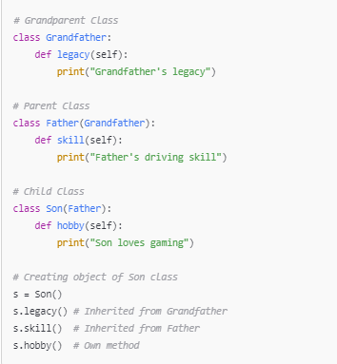

Explanation
- Son inherits from Father, which in turn inherits from Grandfather.
- The Son class gets access to methods from both the parent and grandparent.

4. Hierarchical Inheritance

In hierarchical inheritance, multiple child classes inherit from a single parent class.

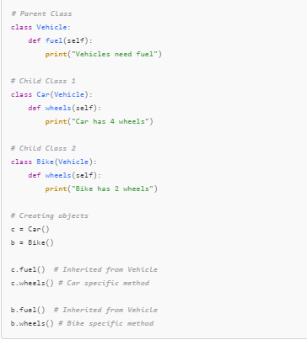

Explanation
- Both Car and Bike inherit the fuel() method from Vehicle.
- Each child class has its own specific method wheels().

5. Hybrid Inheritance
Hybrid inheritance is a mix of two or more types of inheritance.

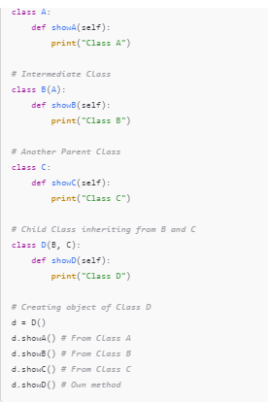

Explanation
- D inherits from both B (which inherits from A) and C.
- D gets access to methods from all its ancestors.
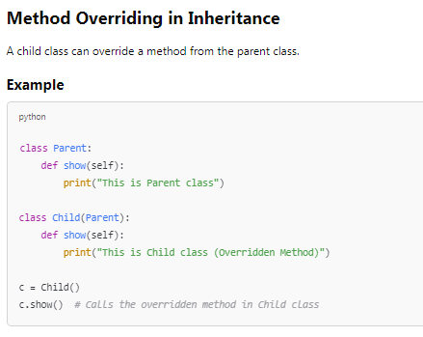

Explanation
- The show() method is overridden in Child, so calling it uses the child's version instead of the parent's.
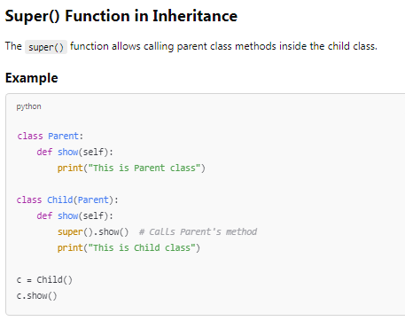

Explanation
- super().show() calls the method of the parent class inside the child class.
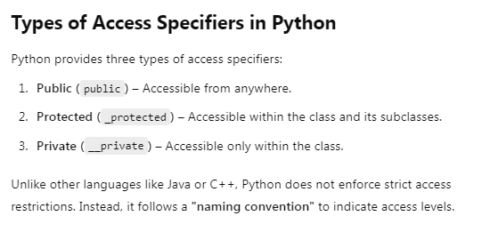
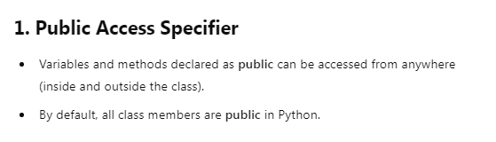
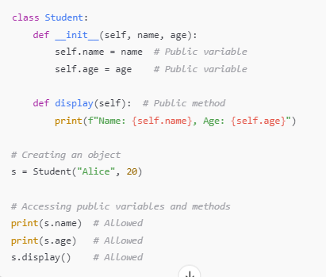

Key Points
✔ Public members can be accessed anywhere.
✔ No restrictions on access.

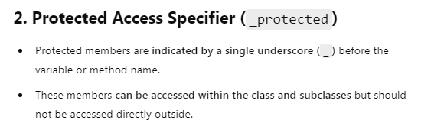
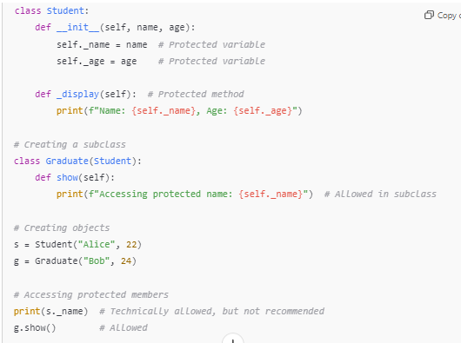

Key Points
✔ Protected members can be accessed in subclasses.
❌ Not recommended to access directly from outside the class.
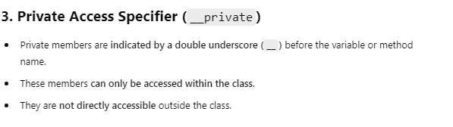
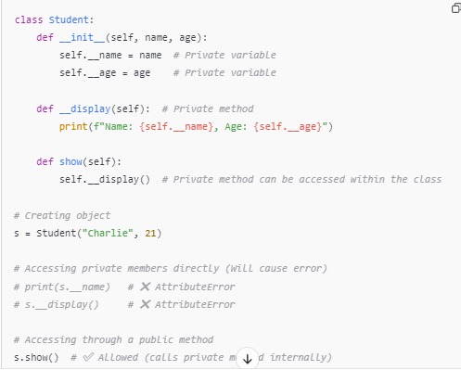

Key Points
✔ Private members are only accessible within the class.
❌ Cannot be accessed directly outside the class.
✔ Can be accessed using a public method within the class.

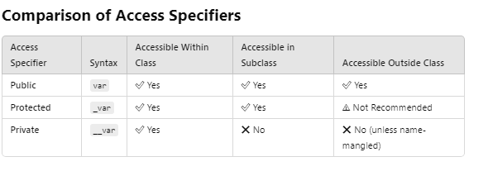

Generator ::
In Python, a generator is a function that returns an iterator that produces a sequence of values when iterated over.

Generators are useful when we want to produce a large sequence of values, but we don't want to store all of them in memory at once.

